ITEM DETAILS
Name of Item | Inter-War Flat
Other Name/s  Former Name/s | 2 Bayview Street, Bronte
Item type | Built
Item group | Flat Building
Item category | Flat
Area, Group, or Collection Name | Unknown
Street number | 2
Street name | Bayview Street
Suburb/town | Bronte |  |  |  |  | Postcode |  |  | 2024
Local Government Area/s | Waverley
Property description | SP 13046
Location - Lat/long | Latitude | -33.90221 |  | Longitude | 151.267985
Location - AMG (if no street address) | Zone |  |  | Easting |  |  |  | Northing
Owner | Private
Current use | Residential
Former Use | Residential
Statement of significance | 2 Bayview Street, Bronte is a fine and intact example of a two- and three-storey freestanding Inter-War Art Deco-style flat building which reflects the development of Bronte, located on a prominent corner site.  It represents the development of Inter-War flat buildings, an important phase in the history of Waverley associated with the changing demographics with a shift to living in flats.  The building demonstrates the demolition of the original house and its replacement with flats, demonstrating an important historical development pattern in the area.  It has historic association has been identified with architect E.C. Pitt and C.C. Phillips.
Level of Significance | National |  | State |  |  |  | Local

DESCRIPTION
Designer | E.C. Pitt and C.C. Phillips
Builder/ maker

Physical Description | 2 Bayview St, Bronte is a two- and three-storey freestanding flat building that dates from the Inter-War period 1940, after the key period of significance of the 1924 subdivision. The building displays features of the Inter-War Art Deco style including symmetrical form, stepped building mass, stepped parapet at entry, decorative face brickwork and vertical fins with elements of Old English in herringbone brick and tudor arch.  The building is setback 1 metre from the street on a large irregular corner site approximately 25 metres wide, that has been amalgamated in a suburban setting that has partially lost its historic context.  The site has a fence of sandstone block and face brick approximately 0.3 metres high, which compliments the setting of the place. The site is large and informally landscaped and features steps, lawn, indigenous and exotic vegetation and provides an appropriate setting for the building.  The plan layout features 3 flats per floor with side/central entry (Type 5 – Waverley Inter-War Flats Study).  The building is in excellent condition and highly intact.  Elements impacting upon the integrity of the site include replacement of roof tiles.
Physical condition  and  Archaeological potential | The building appears to be in excellent condition
Construction years | Start year | 1940 | Finish year | 1940 | Circa
Modifications and dates

HISTORY
Historical notes | Proposed subdivision plans for Bayview St, on the edges of the Bronte Estate, were drawn up from 1861, by Reuss & Browne, for J.J. Falconer, the Superintendent of the Bank of Australasia who was a Bronte landowner and developer. Bay View St appears on Parish Maps in the 1890s and became a formal roadway in the 1920s when it was connected to Bronte parklands via walking paths built by Waverley Council. Marine Drive was constructed as a formal roadway 1931-32, connecting to Bayview St (Draft Waverley Heritage Assessment).  2 Bayview St, Bronte was part of Lot 260 in DP 1033, the Bronte Estate, subdivided in 1883. Lots 260-269 (Block bound by Bayview, Hewlett and Bronte Marine Drive) were re-subdivided under DP 12608 in 1924 by J & A Terrey. Lots 1 and 2 in DP 12608 (the subject site) were purchased by Max Gotch in 1926 (3709-66). Part of the site was transferred to Waverley Council in 1933 and the site was sold to Bertha Burnstein, wife of Roy Burnstein, a leather welding and businessman of Sydney in 1937 (4567-20). The Burnsteins are recorded as resident of ‘Beroya’ Bayview St, Bronte 1933-1941, and from 1944 residence of Point Piper.  Plans for a proposed flat building at the corner of Bayview Road and Marine Drive were prepared by E.C. Pitt and C.C. Phillips for Mrs Bertha Burnstein (nee Lenn) (BR 40/77). The plans were approved by Waverley Council in March 1940. The 1940 plans show a simple building with Functionalist stylistic features including streamlined horizontal bands of windows and a vertical stair, entry elements, horizontal glazing bars and porthole windows. The building, when constructed, diverged from the plans with the adaption of Art Deco stylistic features. A comparation with 1943 aerial photo shows the footprint has not changed.

THEMES
National  historical theme | 4 Building settlements, towns and cities  8 Developing Australia’s Cultural Life
State  historical theme | Towns, suburbs and villages  Land tenure  Accommodation  Domestic life
Local  historical theme | Flats and Bungalows  Speculation and Subdivision

Assessment
A: Historical Significance | 2 Bayview Street, Bronte has historical significance at a local level as it represents the development of Inter-War flat buildings, an important phase in the history of Waverley associated with the changing demographics with a shift to living in flats.  The building has historical significance at a local level as it demonstrates the demolition of the original house and its replacement with flats, demonstrating an important historical development pattern in the area.
B: Associative | To date historic association has been identified with architect E.C. Pitt and C.C. Phillips.
C: Aesthetic significance | 2 Bayview Street, Bronte has aesthetic significance at a local level as a fine and intact example of an Inter-War Art Deco-style flat building located on a prominent corner site.  The building shows an accomplished use of Inter-War Art Deco style which features symmetrical form, stepped building mass, stepped parapet at entry, decorative face brickwork, vertical fins with elements of Old English in herringbone brick and tudor arch.
D: Social significance | To date no social, cultural, and spiritual significance has been identified.
e) Technical/  Research significance | To date no research/technical significance has been identified.
f) Rarity | To date research indicates that 2 Bayview Street, Bronte is not rare.
g) Representative-ness | 2 Bayview Street, Bronte has representative significance at a local level as a fine and intact example of a two- and three-storey freestanding Inter-War Art Deco-style flat building which reflects the development of Bronte.
Integrity | The building is highly intact.

HERITAGE LISTINGS
Heritage listing/s | Draft Waverley LEP 2012

INFORMATION SOURCES
Type | Author/Client | Title | Year | Repository
 |  | Draft Waverley Heritage Assessment | 2020 | Waverley Council
 | Waverley Council | Waverley Heritage Policy | 2007
 | Waverley Council | Waverley Heritage Study | 1993
 | Perumal Murphy Pty Ltd | Waverley Heritage Study | 1990
 |  | Certificate of Title, Vol 3709 Fol66 |  | NSW Land Registry Services
 |  | Certificate of Title, Vol 4567 Fol20 |  | NSW Land Registry Services
Building Plan |  | BR 40/77 |  | Waverley Council

RECOMMENDATIONS
Recommendations

SOURCE OF THIS INFORMATION
Name of study or report | Heritage Policy by Waverley Council reviewed by Architectural Projects 2023 |  | Year of study or report
Item number in study or report

Author of study or report
Inspected by
NSW Heritage Manual guidelines used? |  |  |  | Yes |  | No
This form completed by |  |  |  | Date

IMAGES

Image caption | 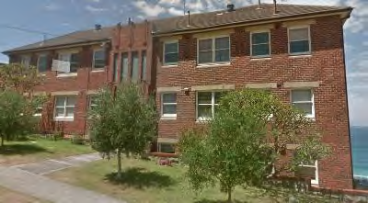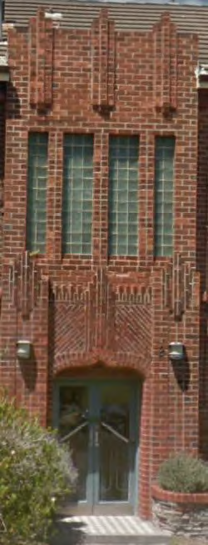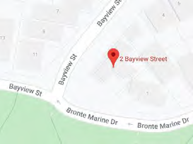
Image year |  | Image by | Google Maps | Image copyright holder

Image caption | 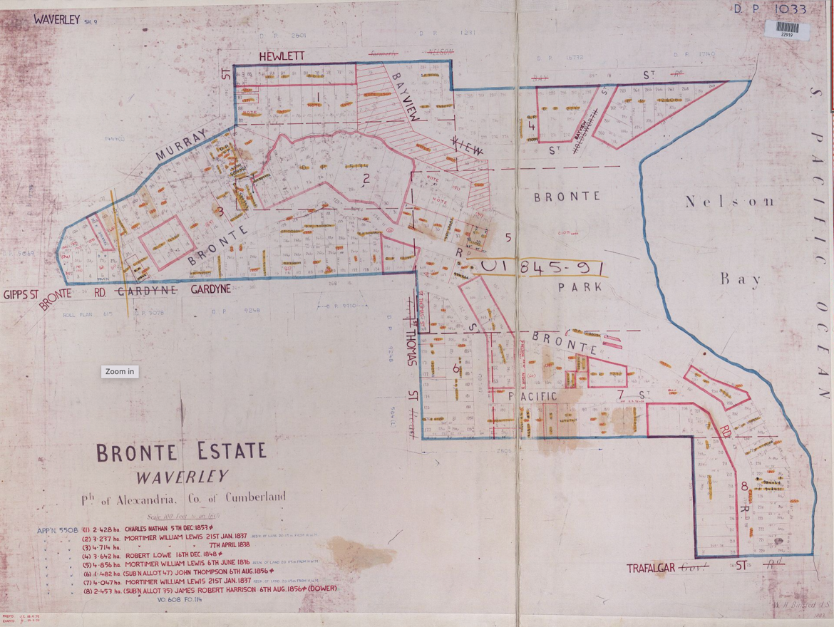
Image year | 1883 | Image by | State Library of New South Wales | Image copyright holder

Image caption | 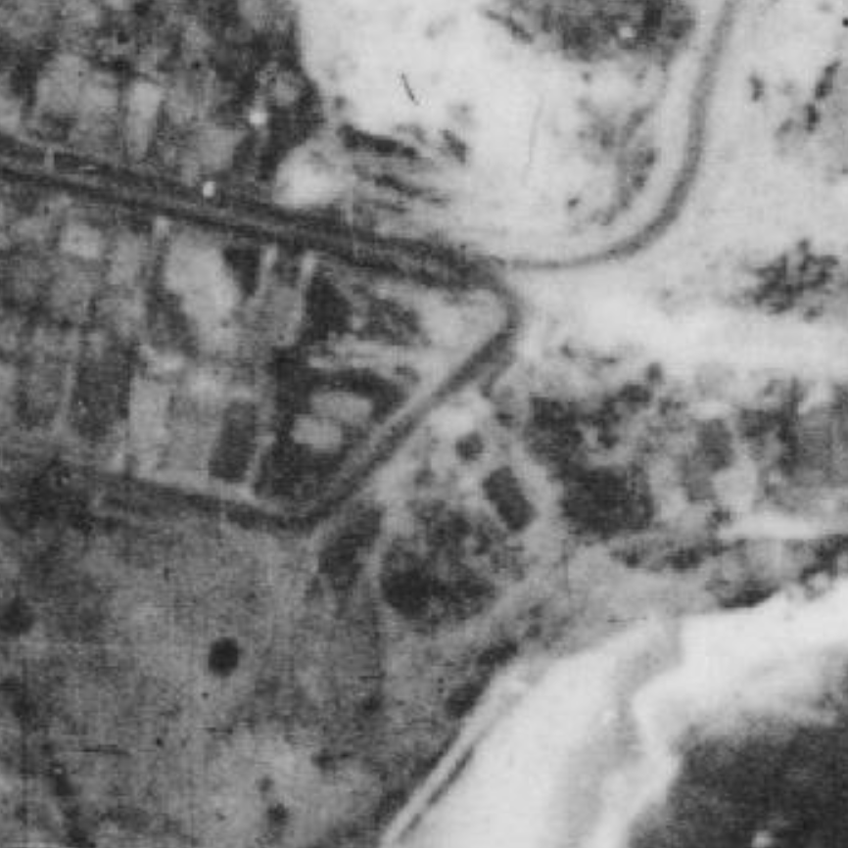
Image year | 1930 | Image by | NSW Historical Imagery | Image copyright holder

Image caption | 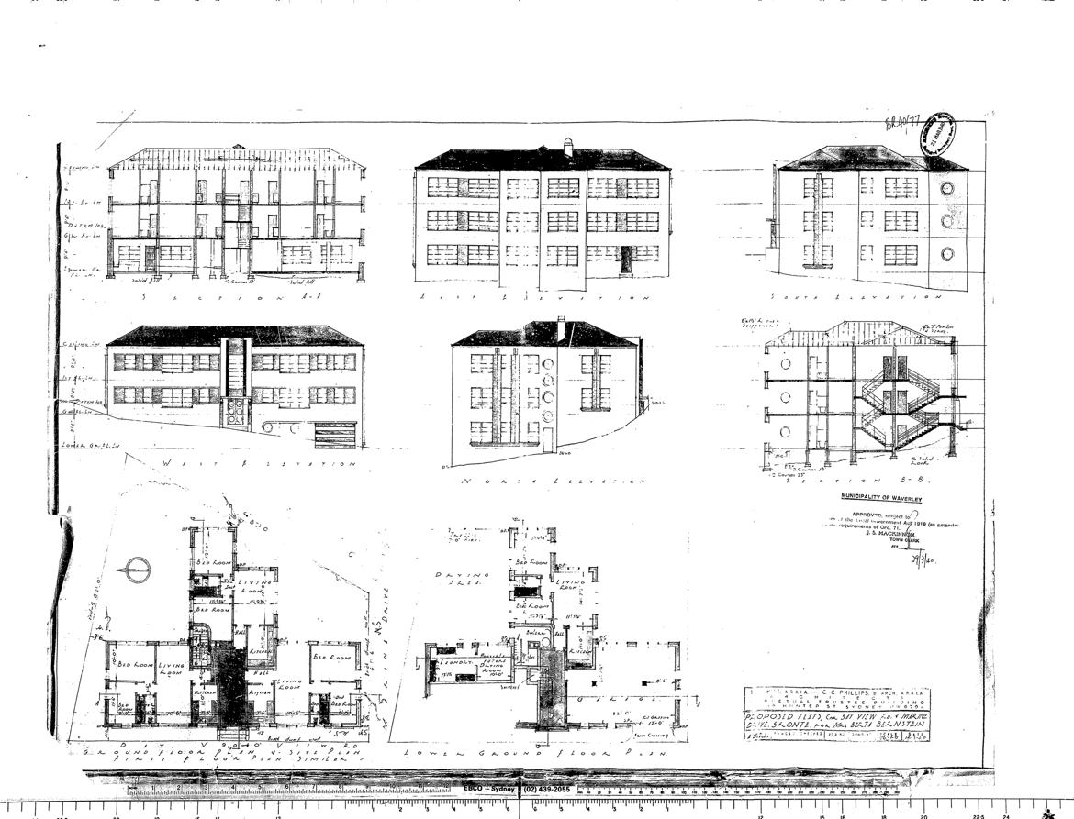
Image year | 1940 | Image by | Waverley Council | Image copyright holder

